**Project Documentation**

**Project Title: FitFlex**

**1. Introduction**

**Project Title:** Fitness Tracker & Wellness Management System

**Team Leader:**

**YOGA LAKSHMI.S**

**Team Members:**

1. **JANA JEEVITHA.D**
2. **JANARTHANAN.S**
3. **JAGADESHWARAN.S**

**2. Project Overview**

**Purpose:**

To promote healthy lifestyles by providing tools for workout planning, nutrition tracking, and progress monitoring.

**Features:**

– Personalized workout and diet plans

– Real-time progress tracking (calories, steps, heart rate)

– Community & chat system for motivation

– Admin control panel for managing users and content

**3. Architecture**

**Frontend:** React.js with Bootstrap & Material UI for interactive dashboards

**Backend:** Node.js & Express.js handling business logic and API endpoints

**Database:** MongoDB storing user profiles, workout history, diet plans, and activity logs

**4. Setup Instructions**

**Prerequisites:**

– Node.js

– MongoDB

– Git

– React.js

– Express.js

– Mongoose

– Visual Studio Code

**Installation Steps:** # Clone the repository git clone <repo-link> # Install client dependencies cd client npm install # Install server dependencies cd ../server npm install

**5. Folder Structure**

FitnessApp/ |-- client/ # React frontend | |-- components/ | |-- pages/ | |-- server/ # Node.js backend | |-- routes/ | |-- models/ | |-- controllers/

**6. Running the Application**

**Frontend:** cd client npm start

**Backend:** cd server npm start

**Access:**

Visit: http://localhost:3000

**7. API Documentation**

**User APIs:**

– /api/user/register

– /api/user/login

**Fitness APIs:**

– /api/workout/create

– /api/workout/:id

– /api/nutrition/track

**Community APIs:**

– /api/chat/send

– /api/chat/:userId

**8. Authentication**

**JWT-based authentication** ensures secure login.

Middleware protects private routes (fitness logs, nutrition details, user dashboards).

**9. User Interface**

**Landing Page:** Overview of app benefits & features

**User Dashboard:** Personalized fitness stats & goals

**Trainer Panel:** Assign workout/diet plans

**Admin Panel:** Manage users, trainers, and reports

**Community Section:** Motivation groups, challenges, leaderboards

**10. Testing**

**Approach:** Manual testing during each milestone

**Tools Used:**

– Postman (API testing)

– Chrome Dev Tools (UI/UX testing)

– Fitness device simulations (API integration testing)

**11. Screenshots / Demo**

*Coding:*

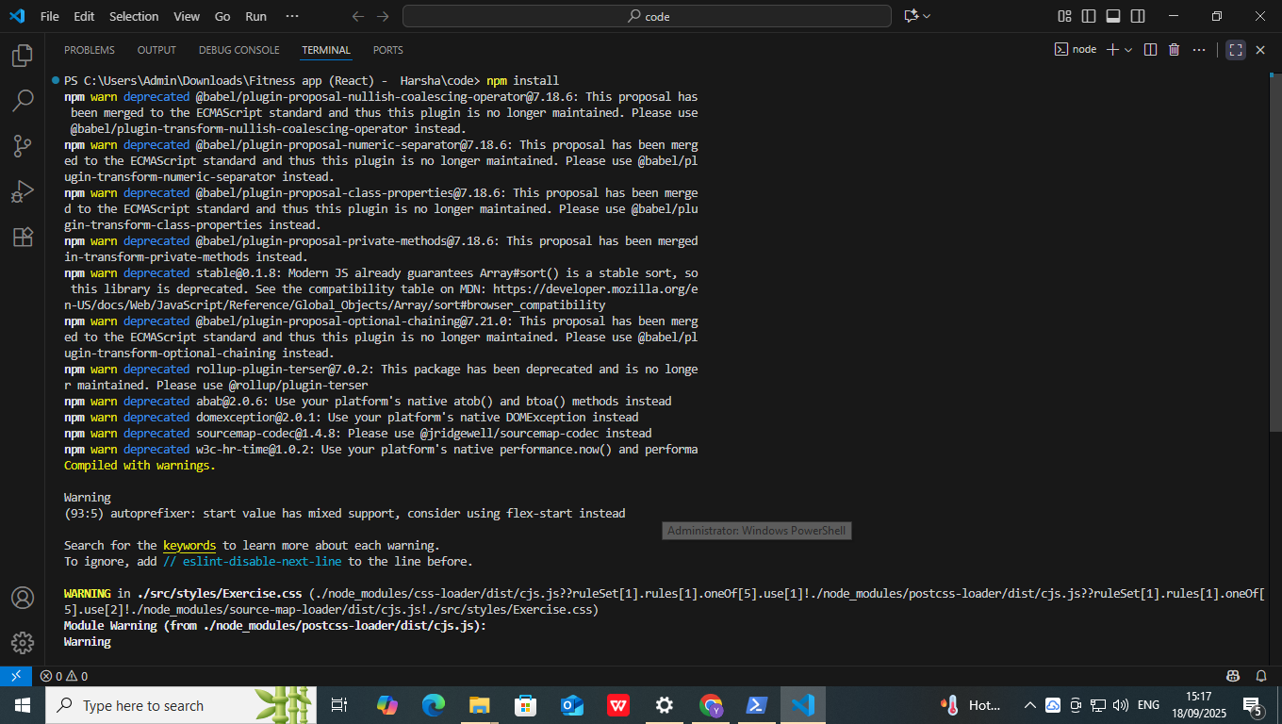

*Output:*

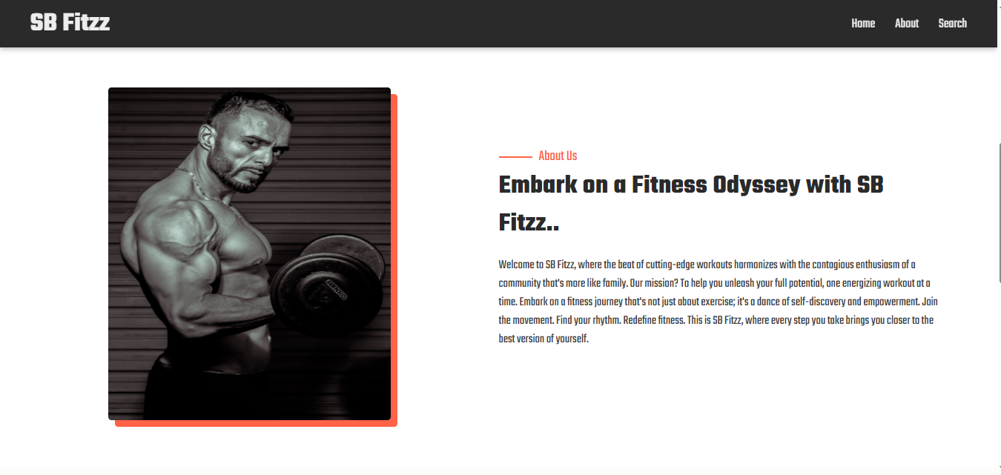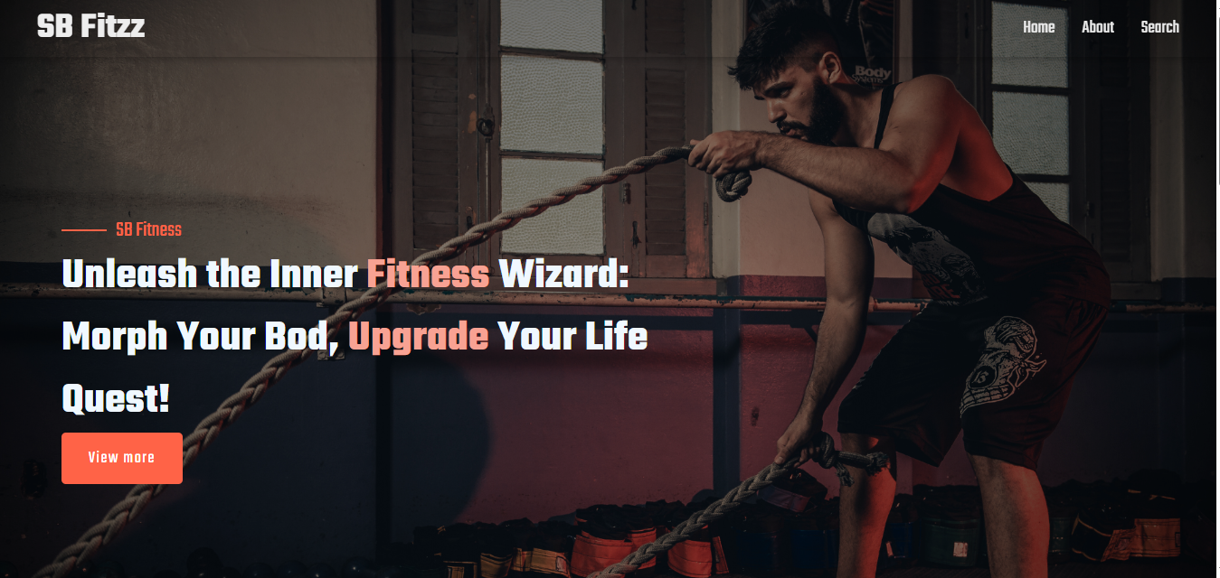

**12. Known Issues**

Limited integration with wearable devices

Offline mode not fully functional

Some APIs still in beta testing

**13. Future Enhancements**

AI-powered personalized workout recommendations

Integration with popular fitness wearables (Fitbit, Apple Watch, Garmin)

Gamification: Rewards, streaks, and fitness challenges

Voice assistant for guided workouts

**14. Video Link**

Link:

*https://drive.google.com/file/d/1ugLZqBydBx58N-SPX7DYjrwznmUAprMX/view?usp=drive_link*